Project handbook
Wetterstation
Projekt Nummer 1

Version 8
Project manager: Brückl Matthias
Date: 24.11.2025

Content

1 Project plans 5
1.1 Project Assignment 5
1.2 Project Objectives (objectives, non-objectives) 6
1.3 Description of Pre- and Post Project Phase 7
1.4 Project Environment Analysis 8
1.5 Relationship to Other Projects and the Organisations´s Strategy 9
1.6 Project Organisation Chart 10
1.7 Plan of Objects of Consideration of the Project 11
1.8 Work Breakdown Structure (WBS) 12
1.9 Project Work-Package Specification 13
1.10 Project Responsibility Matrix 16
1.11 Milestoneplan 17
1.12 Project Bar Chart 18
1.13 Resource Plan 19
1.14 Project Cost Plan 20
1.15 Project Communication 21
1.16 Project „Rules“ 22
1.17 Project Risk Analysis 23
1.18 Project Documentation 24
2 Project Start 25
2.1 Minutes– Project Start 25
3 Project Co-ordination 26
3.1 Approval of Work-packages 26
3.2 Minutes – Project Co-ordination 26
4 Project Controlling 27
4.1 Project Status Report 27
4.2 Additional Project Status Reports 28
4.3 Minutes – Project controlling 28
5 Project Close Down 29
5.1 Project Close Down Report 29
5.2 Minutes – Project Close Down 30

Document versions

Versionno. | Date | Change | Author
1 | 24.11.25 | Start | Brückl M.
2 | 28.11.25 | Objectives and project organization completed | Aistleitner D.
3 | 29.11.25 | Completion till 1.5 | Bergbauer K.
4 | 30.11.25 | Completion till 1.9 | Bergbauer K. / Aistleitner D.
5 | 01.12.25 | 1.4 & 1.9 | Aistleitner D.
6 | 02.12.25 | Finishing the Parts for Project Handbook Part 1 up to 1.10 | Brückl M.
7 | 24.01.26 | Optimizing project environment graphic | Bergbauer K.
8 | 25.01.26 | Update according the feedback | Brückl M.

Distribution list

Name | Organisational Unit | Role in project | Telephone | E-mail
Brückl Matthias | Project Manager | Backend developer | O664 994484299 | Matthias.brueckl@htl-wels.at
Aistleitner Daniel | Project Team Member | Frontend developer | 0677 641591985 | Daniel.aistleitner@htl-wels.at
Bergbauer Klaus | Project Team Member | Hardware and 3d Modelling | 0660 90940434 | Klaus.bergbauer@htl-wels.at
HTL-Wels | Project Owner |  | 0664123456789 | office@htl-wels.at
Smart Flowerpot | Stakeholder | Help with optimizing | 0681 108468979 | Paul.auer@htl-wels.at
Smart Wand | Stakeholder | Help with optimizing | 0677 632238199 | Thomas.toferer@htl-wels.at

Project plans

Project Assignment

Wetterstation  Project no.8 | PROJECT-  ASSIGNMENT
Project start event:  - Submission of the Project shandbook |  | Project start date:  - 12.01.2026
project close down event in terms of content:  - Active usage of the weatherstation  Formal project close down event:  - Handing the weatherstation over to the teacher |  | Project close down dates:  - 10.06.2026
Project objectives:  - Functioning weather station  - Energy-independent power supply  - Web based data analyse  - Minimalist Case |  | Non-objectives:  • No complex data processing  • No guarantee of absolute accuracy of the measurement data.  • No use of cloud storage (e.g., Google Drive, AWS, Azure).  • No failover protection through redundant hardware components.  No remote control
Main tasks (Project phases):  - Conding Frontend  - Read out the date of the sensors  - Coding a small database  - Coding APIs  - 3d modelling the Case |  | Project resources and costs*:
 |  |  | resource/type of cost | unit |  | Costs (€)
 |  |  | Raspberry Pi 2w / A  BME280 / A  DHT22 / A  VEML6075 / A  Breadboard / A  PETG-Filament / A | 1  1  1  1  1  3 |  | 30  5  8  10  5  45
Project owner:  - HTL Wels |  | Project manager:  - Brückl Matthias
Project team members:
- Aistleitner Daniel
- Bergbauer Klaus

<HTL-Wels>, (Project owner) <Matthias Brückl> (Project manager)

* Possible categories of total Project budget:
Category A: up to 0,3 million Euro
Category B: up to 1 million Euro
Category C: up to 10 million Euro
Category D: more than 10 million Euro

Project Objectives (objectives, non-objectives)

Wetterstation  Project no.8 |  | PROJECT  OBJECTIVES
Type of objective | Project objectives |  | Adjusted project objectives as of...
objectives:  - Main objectives  - Additional objectives | - Readout following sensors:  - UV sensor  - Temperature sensor  - Air pressure sensor  - Humidity sensor  - Energy-independent power supply (24 hours 7 days per week)  - Web based data analyse  - Minimalist Case  - Implement a pinwheel to measure wind speed
Non-objectives | • No complex data processing  • No guarantee of absolute accuracy of the measurement data.  • No use of cloud storage (e.g., Google Drive, AWS, Azure).  • No failover protection through redundant hardware components.  • No remote control |  | - If there is enough time left before end of mai this objective could be transformed into an additional object.

Description of Pre- and Post Project Phase

Wetterstation  Project no.8 |  | DESCRIPTION OF  PRE- AND POST-  PROJECT PHASE
- Pre-project phase
What triggered the project?
- An assignment for ITP in school
- The idea of the project was given to us by Brückl’s mom
- She wants to know the exact temperature in her garden

Relevant documents for the project
- Weatherstation_Goals.docx
- Materiallist.docx
- Wetterstation_Pflichtenheft.docx
- Protokoll.docx

Experience from similar projects
- Groupwork SEW in second class (Aistleitner/Brückl/Bergbauer)
- Built a react Website (Brückl)

- Post-project phase
 | - Project will be presented on the “Open House Day” at School

Project Environment Analysis

Wetterstation  Project no.8 | PROJECT ENVIRONMENT GRAPHIC
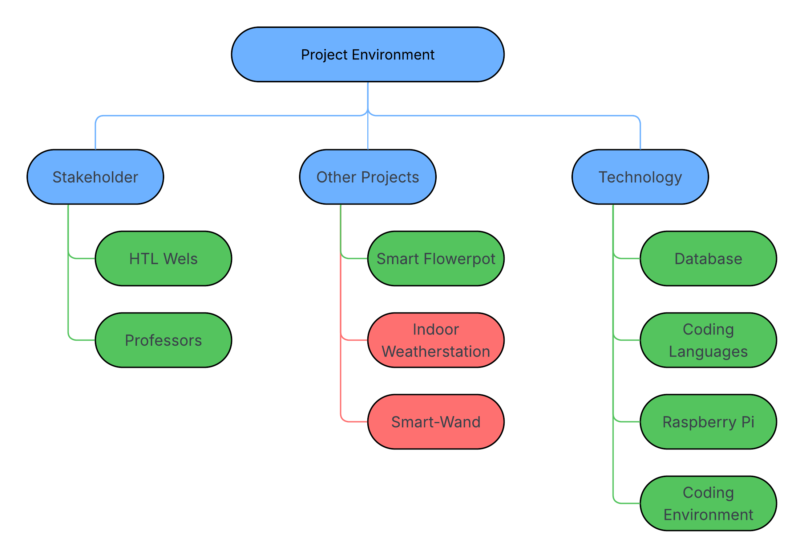

Wetterstation  Project no.8 |  | PROJECT ENVIRONMENT  TABLE
Environment | Relationship  (potential/conflict) |  | Measures |  | Who / when  PSP Code
Stakeholder | potential |  | Can help us to optimize our project |  | HTL-Wels/Professors
Other Projects | conflict |  | Are competition |  | Indoor Wetterstation
Other Projects | potential |  | can help each other |  | Smart-Flowerpot/  Smart-Wand
Technology | potential |  | help us to implement it as we envision it |  | Database/Coding languages/ Raspberry Pi

Relationship to Other Projects and
the Organisations´s Strategy

Wetterstation  Project no.8 |  | RELATIONSHIP TO OTHER PROJECTS
Programs/  Projects/ | Relationship  (potential/conflict) |  | Sanctions | Who / when  WBS Code
Indoor-Wetterstation | Conflict |  | Competition | Paul Gnadlinger; Nicolas Goiginger
Smarter Blumentopf | Potential |  | Support with Know-how | Paul Auer
Smart-Wand | Potential |  | Support with Know-how | Thomas Toferer

Wetterstation  Project no.8 |  | CONNECTION TO THE  ORGANISATION´S STRATEGY
Strategy | Description of connection/relationship
- | -

Project Organisation Chart

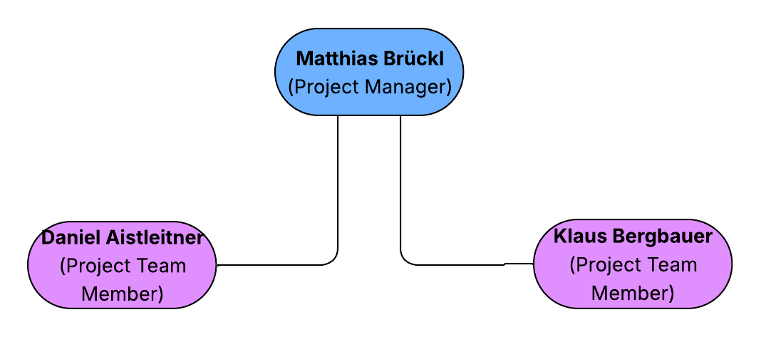

Wetterstation  Project no.8 |  | PROJECT-  ORGANISATION
Role in Project | Field of duties/Skills |  | Name
Project owner | Financial providence |  | HTL Wels
Project manager | Backend development |  | Matthias Brückl
Project team members | - Frontend development  - Hardware and 3d Modelling |  | - Daniel Aistleitner  - Klaus Bergbauer
Project members

Plan of Objects of Consideration of the Project

Wetterstation  Project no.8 | PLAN OF OBJECTS OF CONSIDERATION
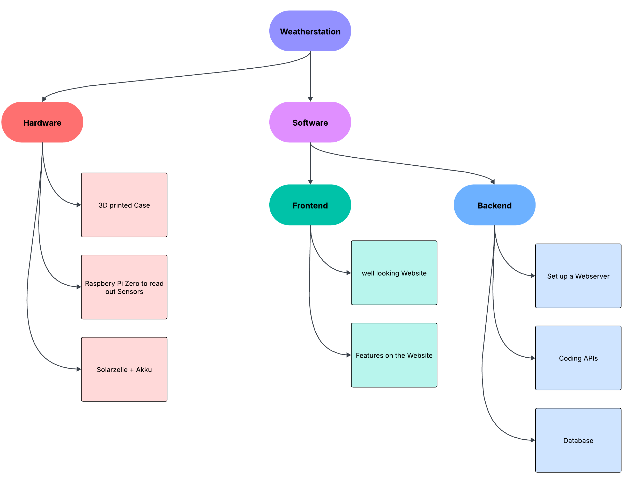

Work Breakdown Structure (WBS)
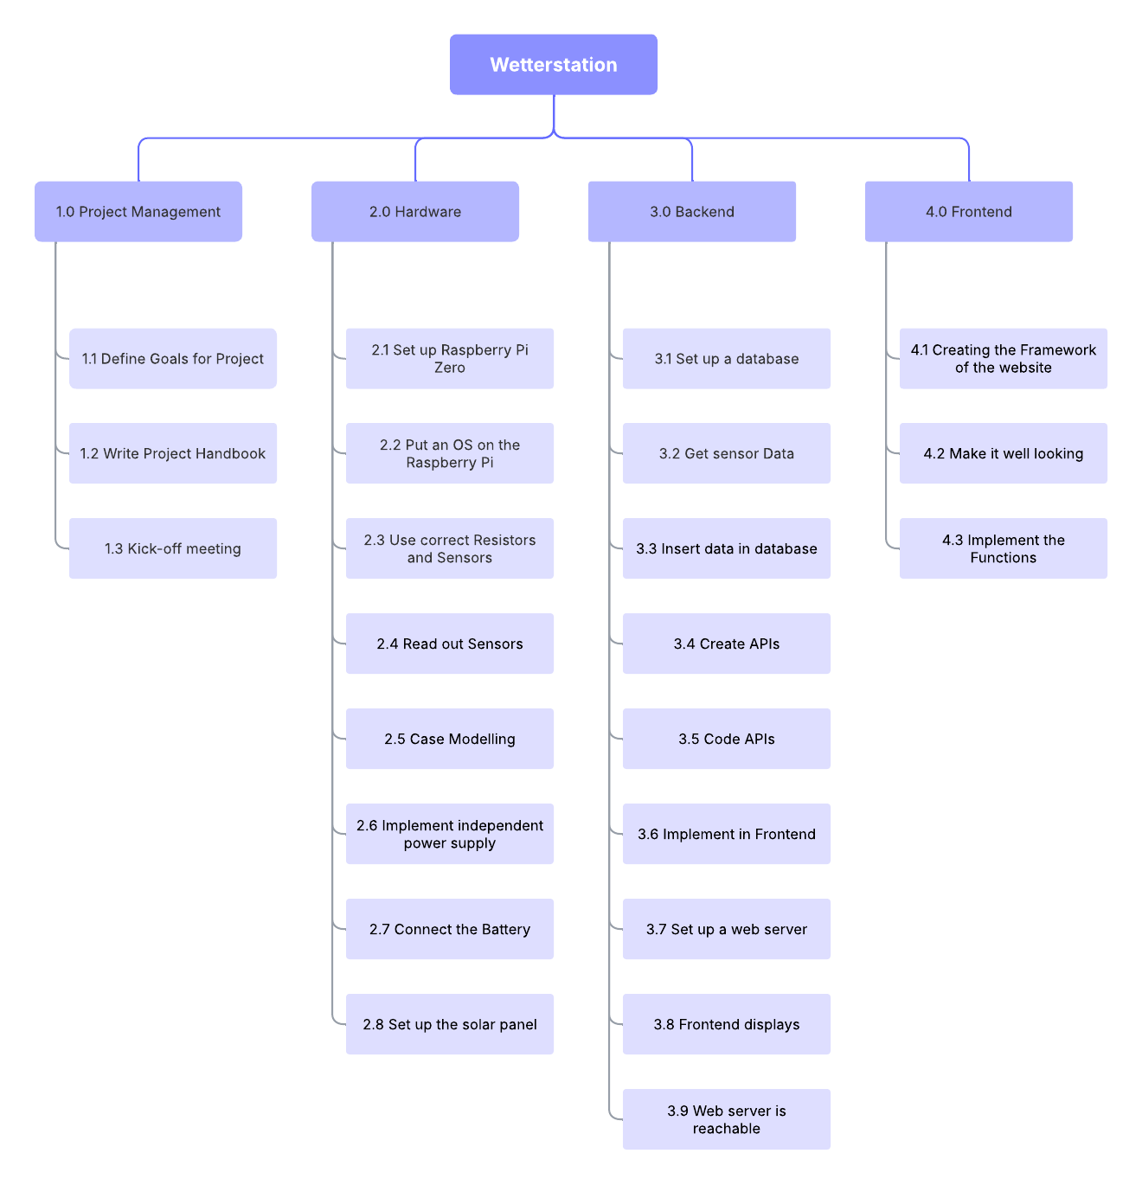

Project Work-Package Specification

Wetterstation  Project no.8 |  | PROJECT WORK-PACKAGE SPECIFICATION
1.1 Raspberry activation | WP Content (What shall be done?)  - Setting up the raspberry
1.1 Raspberry activation | WP Result (What is achieved after WP was finished?)  - Make the raspberry useable
1.1 Raspberry activation | Progress Measurement (How is progress measured?)  - If raspberry is ready
1.2 Sensor implementation | WP Content (What shall be done?)  - Sensor implementing  - Make the data from the sensors usable
1.2 Sensor implementation | WP Result (What is achieved after WP was finished?)  - Make the raspberry useable
1.2 Sensor implementation | Progress Measurement (How is progress measured?)  - If raspberry is ready
1.3 Case modeling | WP Content (What shall be done?)  - Modeling the case of the weather station  - Printing it  - Fine tuning the modulars
1.3 Case modeling | WP Result (What is achieved after WP was finished?)  - Having a ready to use case for the weather station  - Combination with raspberry and other components
1.3 Case modeling | Progress Measurement (How is progress measured?)  - Having a promising model  - Having a successful print  - Making the other components fit
1.4 Energy independent power supply | WP Content (What shall be done?)  - Installing a solar panel for independent power supply
WP Result (What is achieved after WP was finished?)
- The Weatherstation is powered by solar energy.
Progress Measurement (How is progress measured?)
- The Weatherstation is running 24/7
2.1. Basic Framework | WP Content (What shall be done?)  - Programming the Basic Framework of the Frontend
2.1. Basic Framework | WP Result (What is achieved after WP was finished?)  - Creating a functional running program
2.1. Basic Framework | Progress Measurement (How is progress measured?)  - If there are no errors  - Program is running
2.2. Website with not yet functional features | WP Content (What shall be done?)  - Programming the website with the necessary features
2.2. Website with not yet functional features | WP Result (What is achieved after WP was finished?)  - Having a not yet functional website
Progress Measurement (How is progress measured?)
- Control and looking at the website
2.3. Functionalities | WP Content (What shall be done?)  - Programming the functionalities
2.3. Functionalities | WP Result (What is achieved after WP was finished?)  - Sensor-data and printing it out
2.3. Functionalities | Progress Measurement (How is progress measured?)  - If you can see the data on the website
2.4. Design | WP Content (What shall be done?)  - Design of the website
2.4. Design | WP Result (What is achieved after WP was finished?)  - Having a well looking website
2.4. Design | Progress Measurement (How is progress measured?)  - Adding simple elements
3.1. Database | WP Content (What shall be done?)  - Setup a small database to save
WP Result (What is achieved after WP was finished?)
- Having a well modeld Database

Progress Measurement (How is progress measured?)
- Values can be stored effectively

3.2. APIs | WP Content (What shall be done?)  - Coding APIs
WP Result (What is achieved after WP was finished?)
- Frontend can reach Data
Progress Measurement (How is progress measured?)
- Values are displayed on the Frontend

3.3. Web Server | WP Content (What shall be done?)  - Setting up a web server
WP Result (What is achieved after WP was finished?)
- A web server is running
Progress Measurement (How is progress measured?)
- The website that displays the data can be accessed

Project Responsibility Matrix

Wetterstation  Project no.8 |  | PROJECT-  RESPONSIBILITY-  MATRIX
WBS-Code | Roles & Environment  WP-Title |  | External project owner | Project owner | Project manager | Project assistant | Project team member 1 | Project team member 2 | Project team member 3 | Project team member 4 | Project team member 5 |  | Project member 1 | Project member 2 | Project member 3 | Project coach
1.0 | Project Management |  |  | I | R |  | C | C
1.0.1 | Define goals for Project |  |  | I | R |  | C | C
1.0.2 | Write Project-Handbook |  |  | I | R |  | C | C
1.0.3 | Kick-off meeting |  |  | I | R |  | C | C
1.1 | Hardware |  |  | I | C |  | I | R
1.1.1 | Set up the Raspberry Pi Zero 2W |  |  | I | I |  | I | R
1.1.1.1 | Put an OS on the Raspberry Pi Zero |  |  | I | I |  | I | R
1.1.1.2 | Use correct resistors and sensors |  |  | I | I |  | I | R
1.1.1.3 | Read out sensors |  |  | I | C |  | I | R
1.1.2 | Case modeling |  |  | I | I |  | I | R
1.1.3 | Implement independent power supply |  |  | I | I |  | I | R
1.1.3.1 | Connect the battery |  |  | I | I |  | I | R
1.1.3.2 | Setting up the Solar panel |  |  | I | I |  | I | R
1.2 | Backend |  |  | I | R |  | C | C
1.2.1 | Set up a database |  |  | I | R |  | I | C
1.2.1.1 | Get Sensor Data |  |  | I | R |  | I | C
1.2.1.2 | Insert in data in database |  |  | I | R |  | I | C
1.2.2 | Create APIs |  |  | I | R |  | C | I
1.2.2.1 | Code APIs |  |  | I | R |  | I | I
1.2.2.2 | Implement in Frontend |  |  | I | C |  | R | I
1.2.3 | Set up a web server |  |  | I | R |  | C | I
1.2.3.1 | Frontend displays |  |  | I | R |  | C | I
1.2.3.2 | Web server is reachable |  |  | I | R |  | I | I
1.3 | Frontend |  |  | I | I |  | R | I
1.3.1 | Creating the Framework of the website |  |  | I | I |  | R | I
1.3.2 | Make it well looking |  |  | I | I |  | R | I
1.3.3 | Implement the functions |  |  | I | C |  | R | I

Functions
R …….Responsible
C …….Contribution
I ……..has to be informed

Milestoneplan

<Project name>  <Project no.> |  | MILESTONEPLAN
WBS-Code | Milestone |  | Plan date | Revised date |  | Actual date
4 | Finished readable sensors |  | 12.02.2026
7 | Finished case and power supply |  | 30.03.2026
10 | Finished Web UI Foundation |  | 17.03.2026
16 | Finished Database and APIs |  | 26.03.2026
13 | Finished Fronted |  | 29.04.2026
18 | Finished Web Server |  | 15.05.2026
20 | Finished Project |  | 10.06.2026

*In order of plan dates.

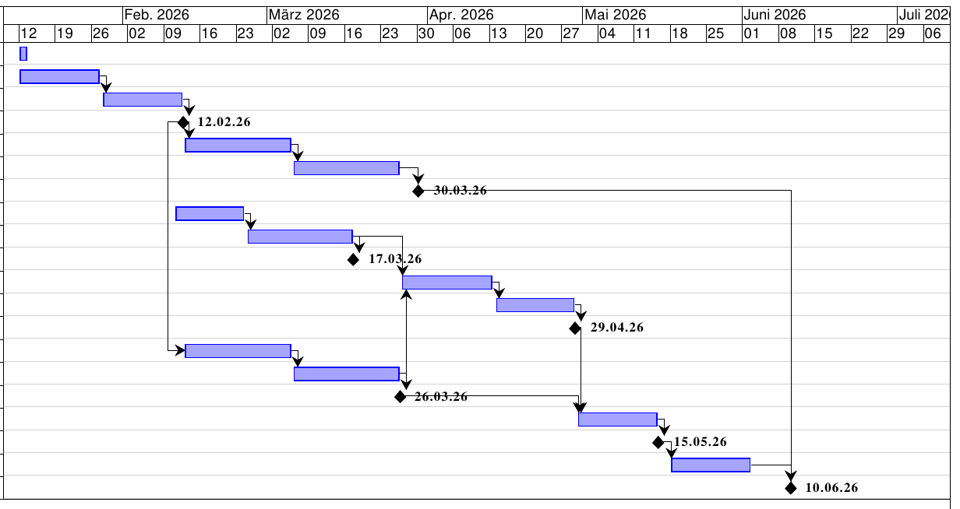
Project Bar Chart

Resource Plan

<Project name>  <Project no.> |  |  | Resource Plan
WBS-Code | Phase/Work-package | Type of resource |  | Planned quantity (days) | Revised quantity (days) | Actual quantity (days) | Deviation  (days)

Project Cost Plan

<Project name>  <Project no.> |  | PROJECT COST PLAN
WBS-Code, WP-Title | Type of Cost |  | Planned cost | Revised cost | Actual cost |  | Deviation
 | - Personnel
 | - Material
 | - External services
 | - Other
 | Total
 | - Personnel
 | - Material
 | - External services
 | - Other
 | Total
 | - Personnel
 | - Material
 | - External services
 | - Other
 | Total
Project cost

Project Communication

<Project name>  <Project no.> |  | PROJECT-  COMMUNICATION
Title | Objectives, Content |  | Participants | Schedule | Location
Project owner meeting | - project status  - decisions  - acceptance of progress report |  | Project owner,  Project manager
Project controlling meeting | - project status  - controlling of tasks, schedule, resources, costs  - controlling of project environments  - social controlling  - prepare proposal for decision |  | Project manager,  Project team,  Project coach
Subteam meeting | - Coordination of subteams  - Discussion of problems |  | Subteam

Project „Rules“

Project Risk Analysis

 |  | PROJECT RISK ANALYSIS
WBS-  Code | WBS-  description | Risk-  description | Priority | Benefit  /Cost | Probability | Risk-  value | Delay | Avoiding action | Cost for minimizing risk
(Code) | (Text) | (Text) | (Range) | (iuro) | (Percentage) | (iuro) | (iWeeks) | (Text) | (Euro)
Project total

Project Documentation

Area | Description
File
Access Authorisation
Naming convention
Rules

Project Start

Minutes– Project Start

Project Start Workshop

Follow-up Workshop

Project Owner Meeting

Project Co-ordination

Approval of Work-packages
<Project name>  <Project no.> |  | APPROVAL OF  WORK-PACKAGES
WBS-Code | Work-package |  | WP-Owner | Date | Approval by | Signature

Minutes – Project Co-ordination

Project Controlling

Project Status Report
<Project name>  <Project no.> | PROJECT STATUS REPORT  as of ........
    Project crisis  Project in difficulties  Project according to plan |  | - Overall Status:
2) Status Project objectives |  |  | Activities:
3) Status Project progress |  |  | Activities:
4) Status Schedule |  |  | Activities:
5) Status Resources/costs |  |  | Activities:
6) Status Context |  |  | Activities:
7) Status Organisation/culture |  |  | Activities:

Additional Project Status Reports

Minutes – Project controlling

Project Controlling Meetings

Project Owner Meetings

Project Close Down

Project Close Down Report

<Project name>  <Project no.> |  | PROJECT CLOSE DOWN REPORT
- Overall impression |  |  | - Reflection: Fulfilment of objectives
- Reflection: Deliverables / Schedule

- Reflection: Resources / Costs

- Reflection: Internal Organisation / Environmental Relationships

- Performance appraisal (Project owner, Project manager, Project member) |  |  | - Lessons learned (Summary of Experiences and suggestions for improvement)
- Post-Project Phase Planning, Additional Tasks
 | To-Do |  |  | Owner |  | Schedule
- Project Close Down

<Name> (Project owner) <Name> (Project manager)

Minutes – Project Close Down

Project Close Down Workshop

